Fixed params
main_session_kwargs = {
"amount_of_rounds": 4,
"type_preferences": ["level", "level", "balanced", "balanced"],
"gender_preferences": ["open", "mixed", "mixed", "open"],
"weight_same_teammate": 5,
"first_seed": 0,
"last_seed": 9,
"spectrum": True,
"rounds_reordering": [3, 4, 2, 1],
"print_progress": False,
}

First idea with given sample, fine tuning
Sample chosen
df = main.main_df.loc[
[
"VictorDa",
"David",
"Félix",
"Leila",
"Dominik",
"Angela",
"Colin",
"Leo",
"FlorianD",
"Sarah",
"Enzo",
"Aliénor",
"Emma",
]
]

Level_gap_tol
Other params:
lambda_weight = 0.5 # Fixed lambda_weight for this sweep
num_iter = 350 # Fixed num_iter for this sweep

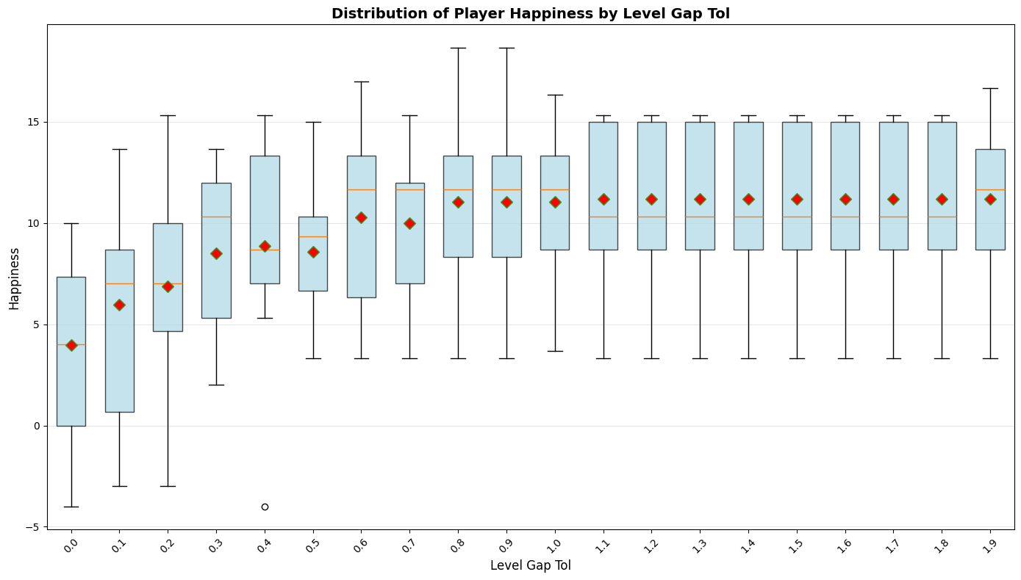Looks like 1.1 is a good bet

Num_iter
lambda_weight = 0.5 # Fixed lambda_weight for this sweep
level_gap_tol = 1.1 # Fixed level_gap_tol for this sweep
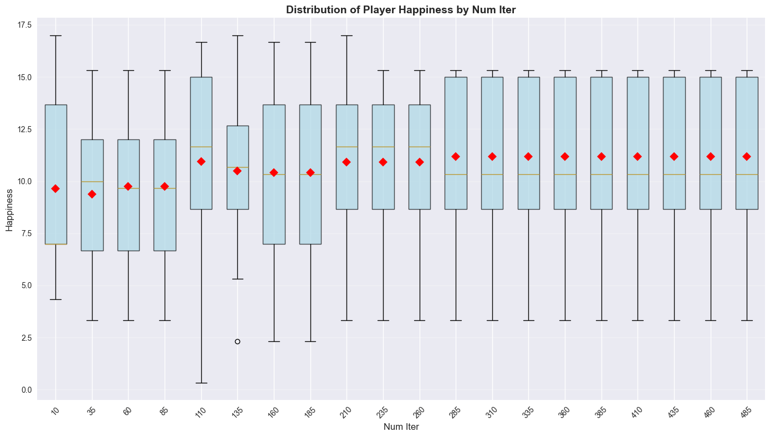
300 looks safe

Lambda_weight with mean_min_max
level_gap_tol = 1.1 # Fixed level_gap_tol for this sweep
num_iter = 300 # Fixed num_iter for this sweep
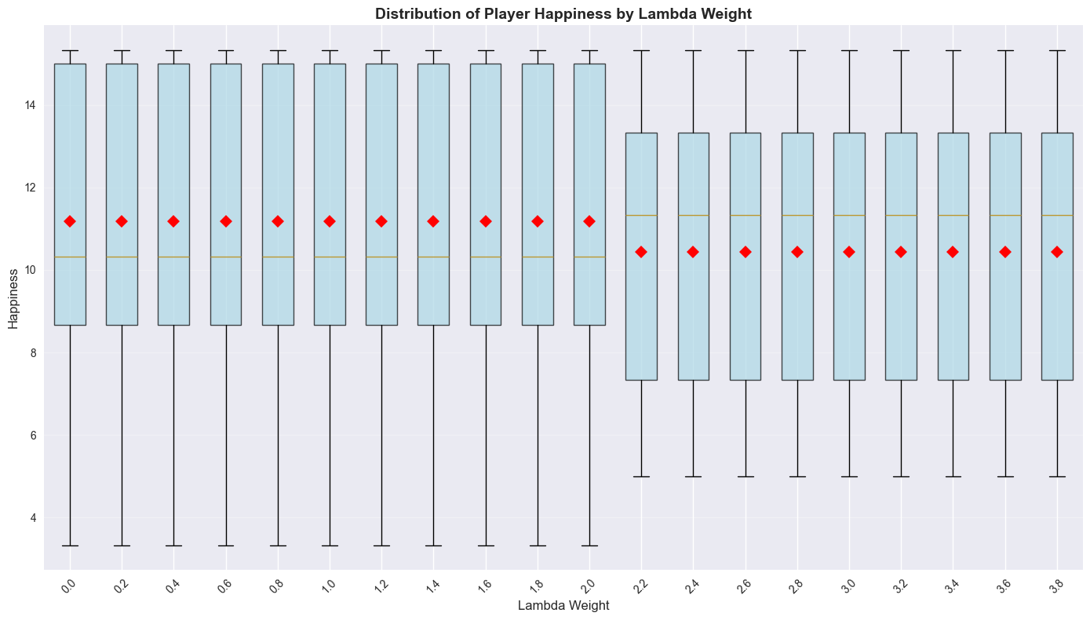
2.4 looks nice

Generating random samples

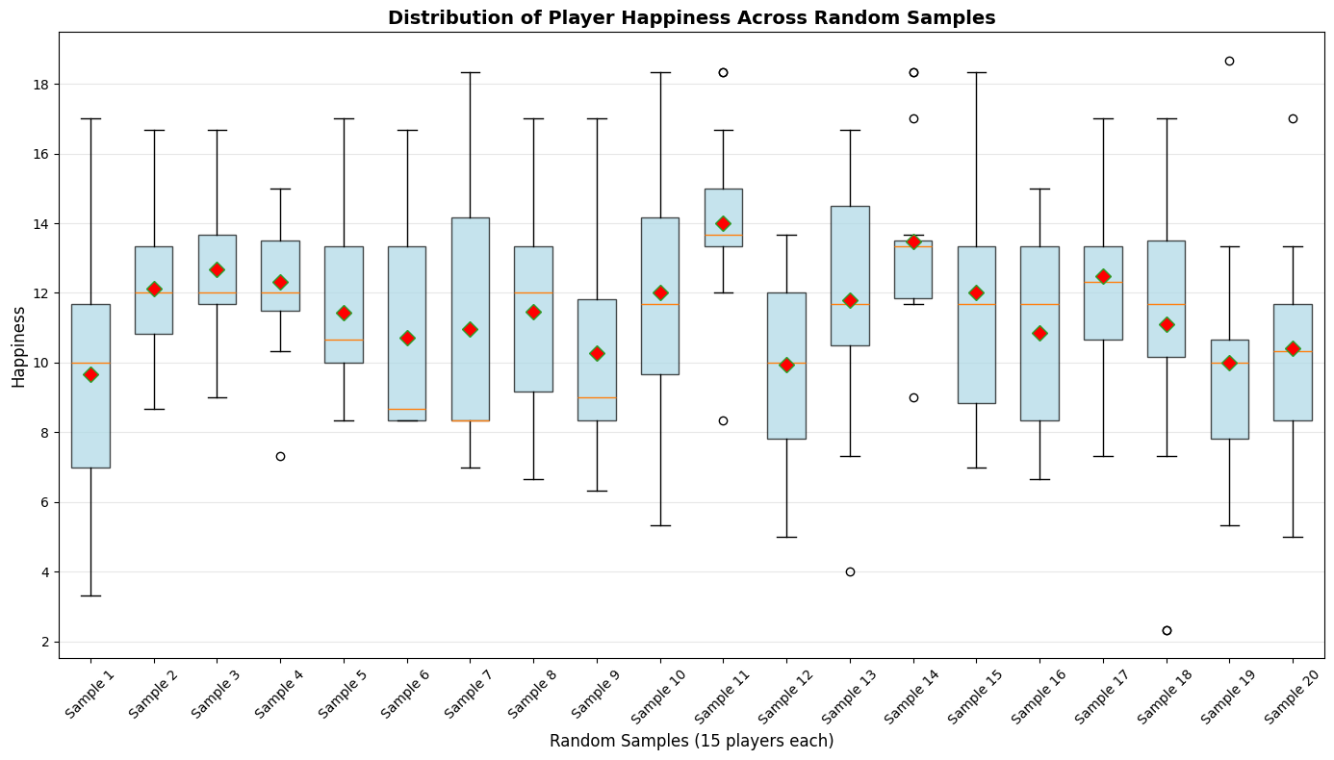
Sample n°1 looks the worst. We’ll redo the same fine tuning to see if we have the same params:

Redoing fine tuning
df = main.main_df.loc[
[
"Patrick",
"Angela",
"Sarah",
"Alissa",
"Marco",
"Thibault",
"Chiara",
"Emma",
"François",
"Luciano",
"Leo",
"FlorianD",
"Leila",
"Anyel",
"Lucas",
]
]

Level_gap_tol
lambda_weight = 0.5 # Fixed lambda_weight for this sweep
num_iter = 350 # Fixed num_iter for this sweep

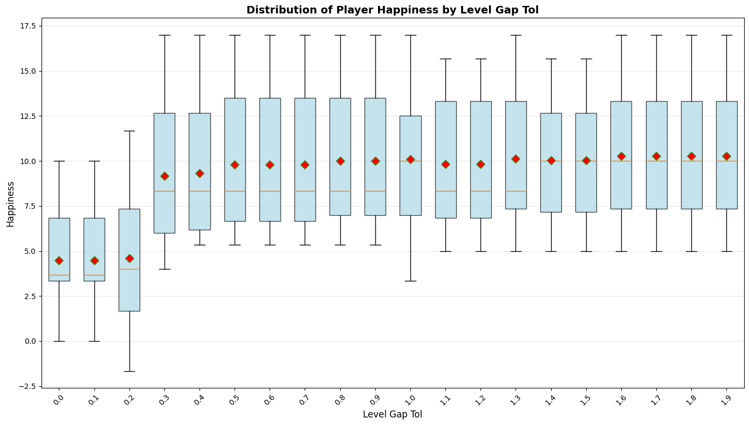
1.7 looks better, but it’s maybe too big. Keeping 1.1

Num_iter
lambda_weight = 0.5 # Fixed lambda_weight for this sweep
level_gap_tol = 1.1 # Fixed level_gap_tol for this sweep

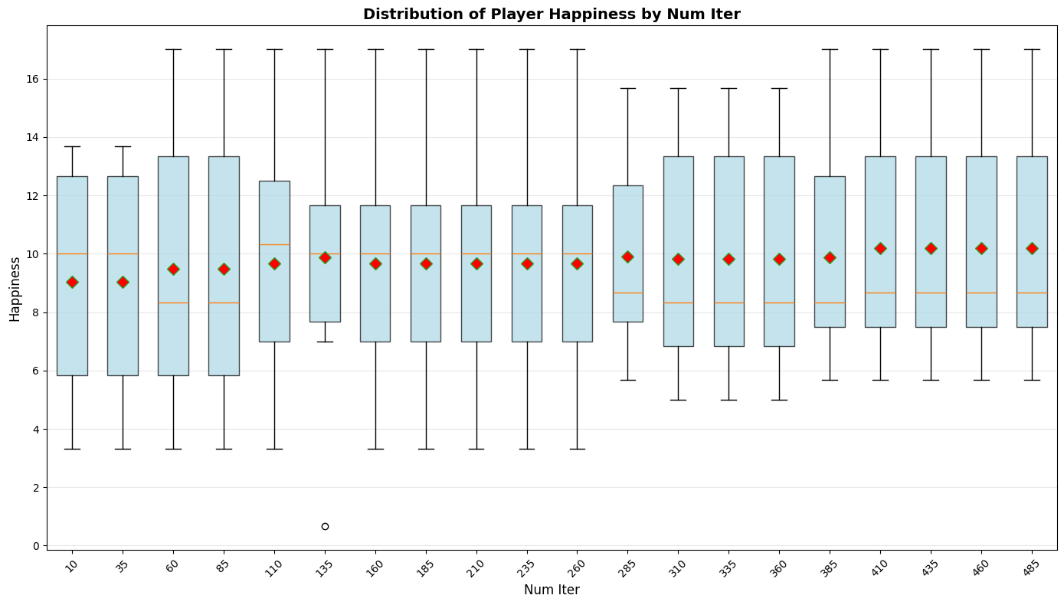
350 not so bad, but 435 looks safer, and in the preceeding it doesn’t change anything

Lambda_weight
level_gap_tol = 1.1 # Fixed level_gap_tol for this sweep
num_iter = 435 # Fixed num_iter for this sweep
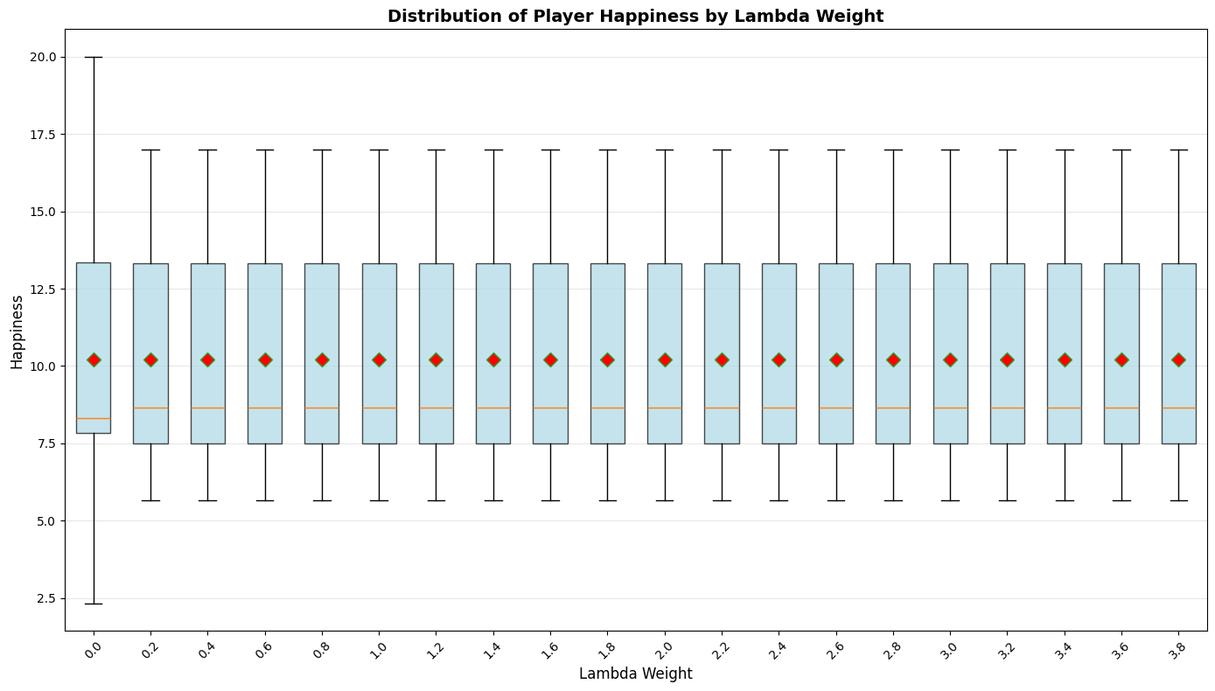
Looks like the weight is already effective with small value. Checking closer:
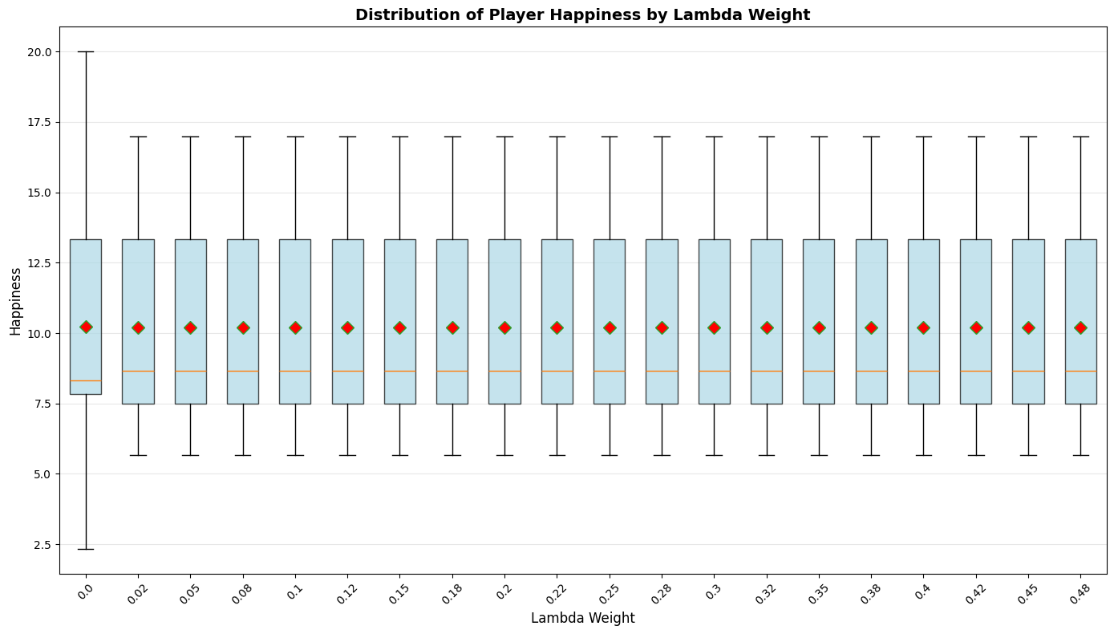
Looks like osef

Params chosen:
level_gap_tol = 1.1 # Fixed level_gap_tol for this sweep
num_iter = 435 # Fixed num_iter for this sweep
lambda_weight = 2.4

